Togo

## Respect for rule of law (ROL) data

The data set shows the data on the respect of the rule of law for the country.

## # A tibble: 19 x 5  
## country iso3c date ruleOfLaw ruleOfLawCategory4   
## <chr> <chr> <dbl> <dbl> <chr>   
## 1 Togo TGO 1996 -0.731 ROL moderately disrespected  
## 2 Togo TGO 1998 -0.728 ROL moderately disrespected  
## 3 Togo TGO 2000 -0.702 ROL moderately disrespected  
## 4 Togo TGO 2002 -0.784 ROL moderately disrespected  
## 5 Togo TGO 2003 -0.930 ROL moderately disrespected  
## 6 Togo TGO 2004 -1.11 ROL highly disrespected   
## 7 Togo TGO 2005 -1.08 ROL highly disrespected   
## 8 Togo TGO 2006 -0.943 ROL moderately disrespected  
## 9 Togo TGO 2007 -0.923 ROL moderately disrespected  
## 10 Togo TGO 2008 -0.825 ROL moderately disrespected  
## 11 Togo TGO 2009 -0.882 ROL moderately disrespected  
## 12 Togo TGO 2010 -0.922 ROL moderately disrespected  
## 13 Togo TGO 2011 -0.878 ROL moderately disrespected  
## 14 Togo TGO 2012 -0.928 ROL moderately disrespected  
## 15 Togo TGO 2013 -0.973 ROL moderately disrespected  
## 16 Togo TGO 2014 -0.857 ROL moderately disrespected  
## 17 Togo TGO 2015 -0.799 ROL moderately disrespected  
## 18 Togo TGO 2016 -0.634 ROL moderately disrespected  
## 19 Togo TGO 2017 -0.713 ROL moderately disrespected

## Respect for rule of law (ROL) trend

The plot shows the trend of the respect for the rule of law for the country.

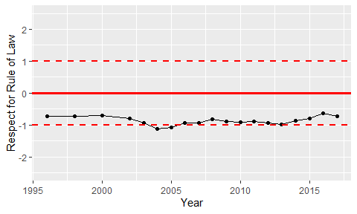

Trend of the Respect for the Rule of Law